Console App Menu:

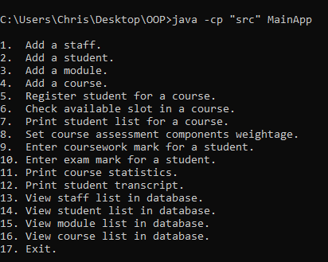

1. Load Staff/Student/Module/Course list from csv file

1. Staff List

|  |  |
| --- | --- |
| Test Case | Expect Outcome |
| View Staff List immediately after application start | 4 pre-set professors display |

Screenshot:

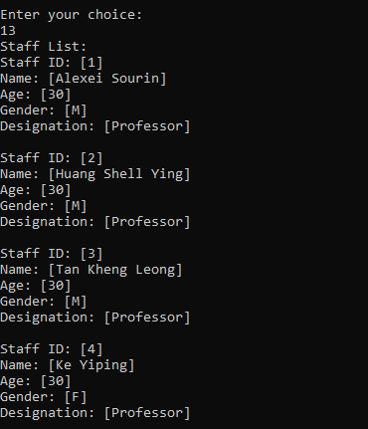

1. Student List

|  |  |
| --- | --- |
| Test Case | Expect Outcome |
| View Student List immediately after application start | 15 pre-set students display |

Screenshot:

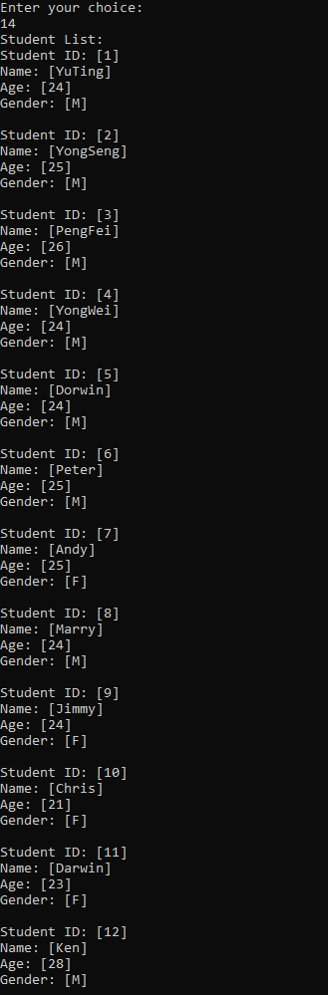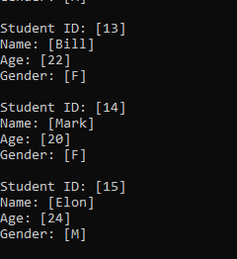

1. Module List

|  |  |
| --- | --- |
| Test Case | Expect Outcome |
| View Module List immediately after application start | 10 pre-set modules display |

Screenshot:

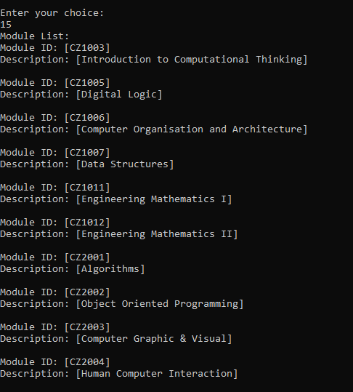

1. Courses list

|  |  |
| --- | --- |
| Test Case | Expect Outcome |
| View Course List immediately after application start | 15 pre-set students display |

Screenshot:

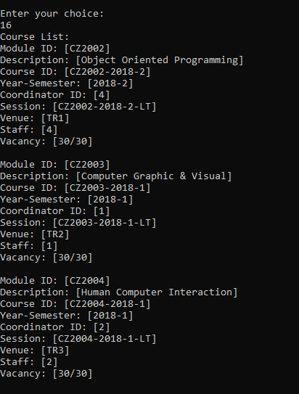

2. Add staff.

|  |  |
| --- | --- |
| Test Case | Expect Outcome |
| 1. Add a new staff | The listing of all staffs should be displayed after the addition. |
| 1. Add an existing staff (duplicated staff ID) | Appropriate error message display |
| 1. Non-numeric input for ages | Appropriate error message display |

Screenshots:

a.

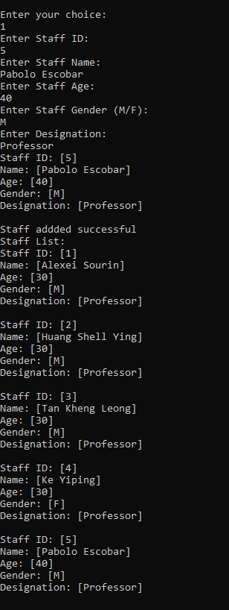

b.

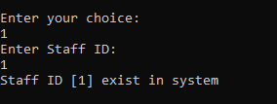

c.

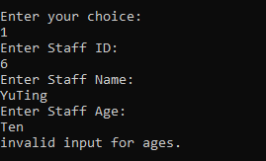

3. Add Student.

|  |  |
| --- | --- |
| Test Case | Expect Outcome |
| 1. Add a new Student | The listing of all students should be displayed after the addition. |
| 1. Add an existing staff (duplicated staff ID) | Appropriate error message display |
| 1. Non-numeric input for ages | Appropriate error message display |

Screenshots:

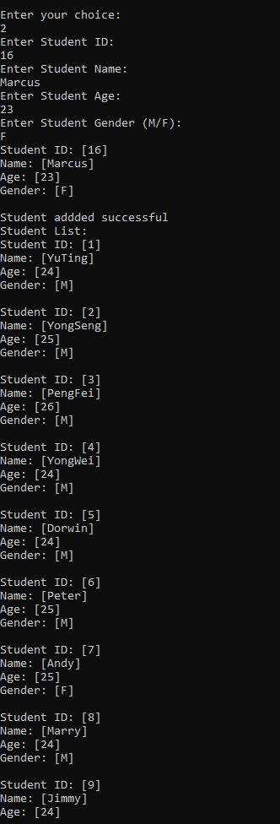

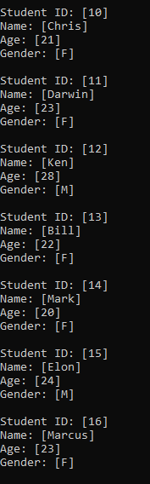

b.

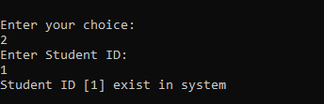

c.

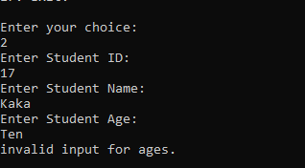

4. Add Module.

|  |  |
| --- | --- |
| Test Case | Expect Outcome |
| 1. Add a new Module | The listing of all Module should be displayed after the addition. |
| 1. Add an existing Module (duplicated Module ID) | Appropriate error message display |

Screenshots:

a.

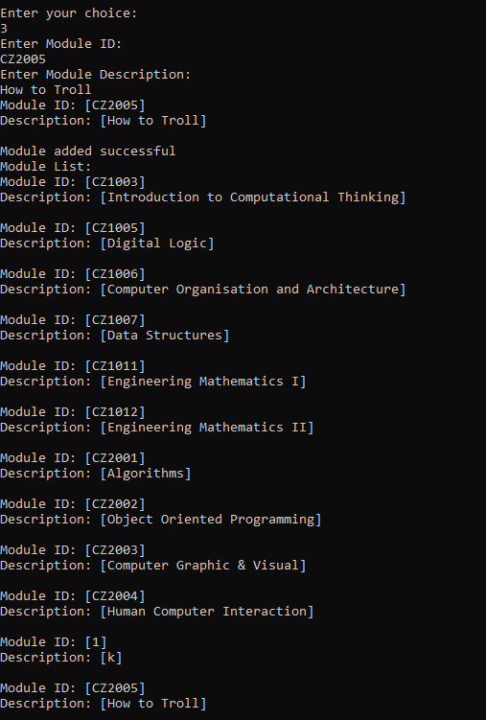

b.

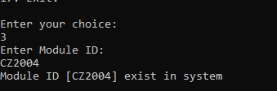

4. Add Course.

|  |  |
| --- | --- |
| Test Case | Expect Outcome |
| 1. Add a new Course (only 1 Lecture group) | The listing of all Course should be displayed after the addition. |
| 1. Add a new Course (1 Lecture group + 2 Tutorial group) | The listing of all Course should be displayed after the addition. |
| 1. Add a new Course (1 Lecture group + 2 Tutorial groups + 2 Lab groups) | The listing of all Course should be displayed after the addition. |
| 1. Invalid input | Appropriate error message display |
| 1. Add duplicated course | Appropriate error message display |

Screenshots:

a.

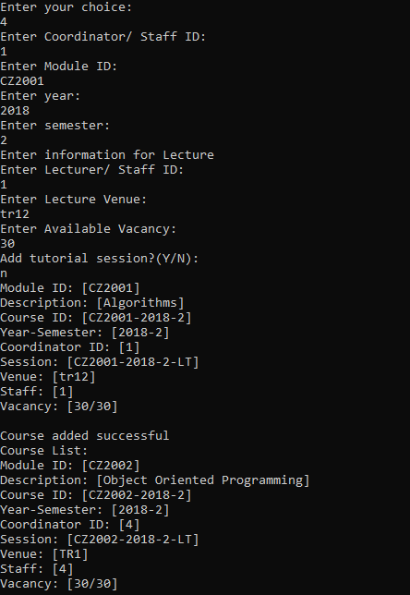

…

b.

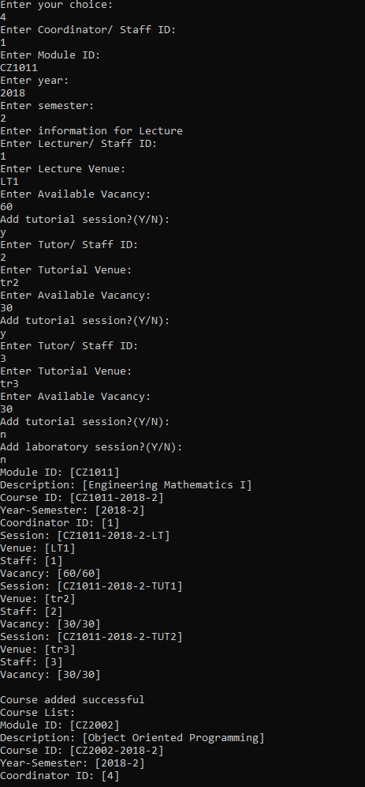

c.

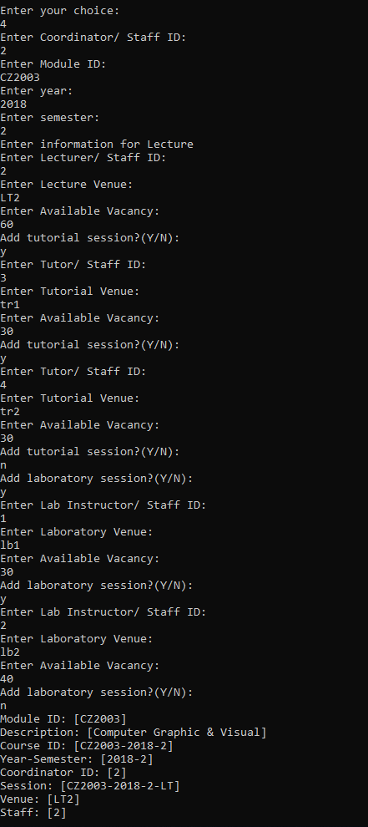

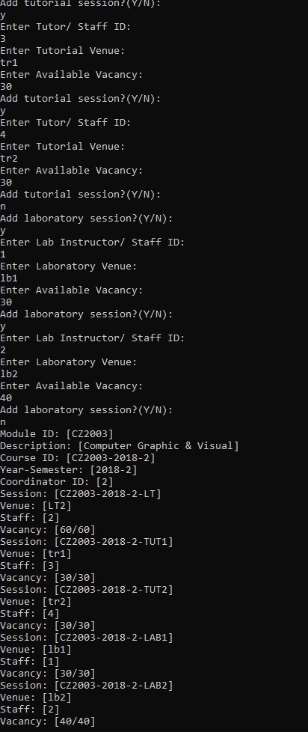

d.

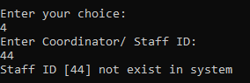

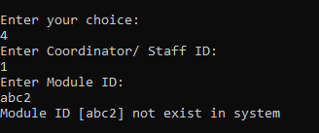

e.

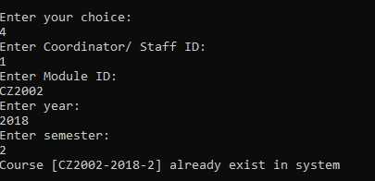

5. Register student for a course

|  |  |
| --- | --- |
| Test Case | Expect Outcome |
| 1. Add a student to a course with available vacancies in Tut / Lab. | Appropriate message display |
| 1. (i) Add a student to a course with 0 vacancies in Tut / Lab. | Appropriate message display |
| 1. Register the same course again | Appropriate error message display |
| 1. Invalid data entries (eg wrong student ID / course code, etc) | Appropriate error message display |
|  |  |

Screenshots:

a.

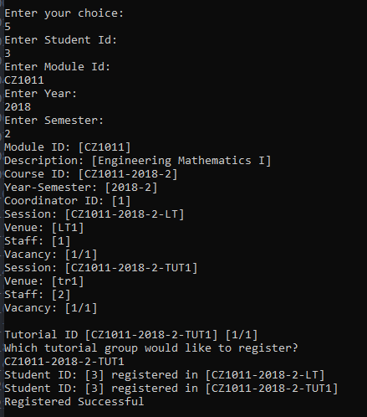

b.

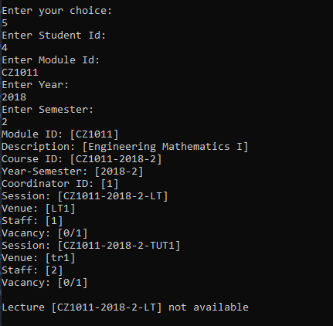

c.

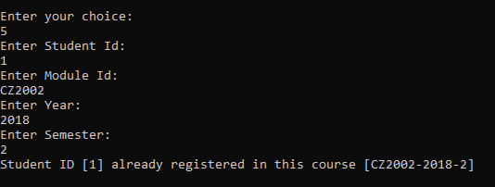

d.

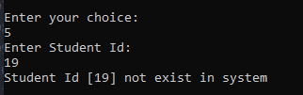

6. Check available slot in a class (vacancy in a class).

a. Check for vacancy.

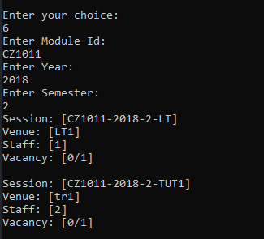

b. invalid input.

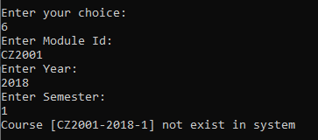

7. Print student list by lecture, tutorial or laboratory session for a course.

Print list by choice:

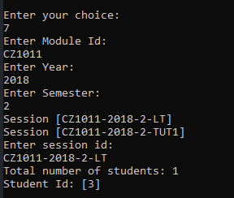

Invalid input:

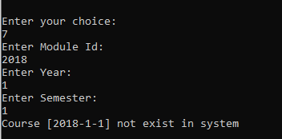

8. Enter course assessment components weightage

a. set exam-course work percentage

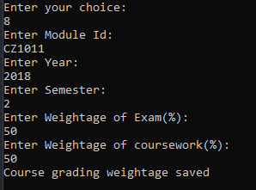

b. invalid input

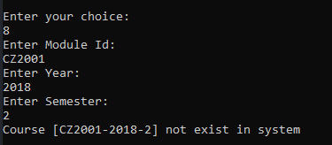

9. Enter coursework mark

Set coursework mark:

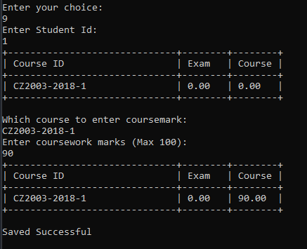

Student no register for a course:

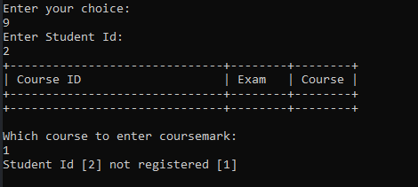

10. Enter exam mark

Set exam mark:

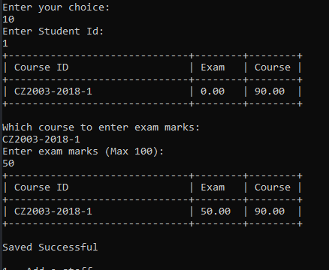

11. Print course static.

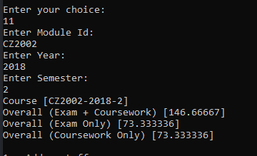

12. Print student transcript.

